Instructions to Prepare a Paper for the 24th International Symposium on Advanced Technology

First A. Author, Second B. Author*, and Third C. Coauthor

Department of XXXXX, Graduate School of Engineering, Kogakuin University, Tokyo, Japan
E-mail: your_address@xx.xxxx.xxx

Abstract
This document gives formatting instructions for authors preparing papers for publication in the 24th International Symposium on Advanced Technology (ISAT-24). The authors must follow the instructions given in this document for the papers to be published.

The paper must be written in English, A4 paper, single-spaced, justified, with a font size of 10 pt, in Times New Roman. The margins must be formatted to 2.5 cm on all sides of the paper. The header and footer must be 2.0 cm. Abstracts should generally be 1 to 2 pages long; however, submissions of up to 6 pages will be accepted if necessary (including photo and drawing) in A4 size. Photos & drawings must be 300dpi or higher in resolution.
The title should be written centered, in 12pt, boldface Times New Roman letters. It should be single spaced if the title is more than one line. The authors’ name should include first name, middle initial and surname. It should be written centered, in 10pt boldface Times New Roman, below the title. Authors' affiliation should be written centered, in 10pt, Times New Roman, below the authors’ name.
The page will include the Editorial Heading, as shown in this page of this instruction. Please do not number the pages of the paper.
Tables and figures must be integrated with the text and numbered consecutively in the order in which reference is made to them in the text of the paper. All captions must be italicized and centrally located above a table and below a figure. The first table or figure caption would be referred to in the text as Table 1 or Fig. 1 and be presented as follows:
Table 1. Table captions should be centered and placed above the figure.
Film | v / nmol L^{–1} min^{–1}
Film | UV | vis | Dark
R | 25(1) | 17(1) | 3(1)
R-PA15 | 20(1) | 15(1) | 3(1)
R-PA30 | 21(1) | 16(1) | 3(1)

A displayed equation is numbered, using Arabic numbers in parentheses. It should be centered, leaving an 8pt space above and below to separate it from the surrounding text.
References should be quoted in the text by superscript numbers, and grouped together at the end of the paper in numerical order as shown in these instructions ^{[1]}.
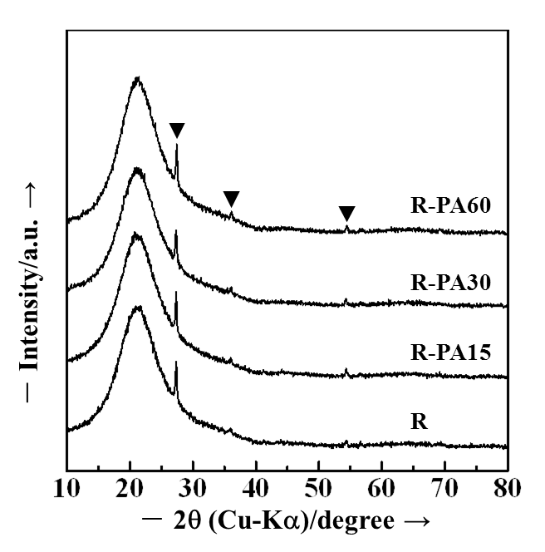
Fig. 1. Figure captions should be centered and placed below the figure.
All submissions must be through website.
Inquiries: isat@sc.kogakuin.ac.jp.
Deadline for the submission is September21, 2025.

References:
- Y. Ohko, T. Tatsuma, T. Fujii, K. Naoi, C. Niwa, Y. Kubota, A. Fujishima, Nature Materials, 2, 29−31 (2003).
- H. Nagai, S. Aoyama, H. Hara, C. Mochizuki, I. Takano, N. Baba, M, Sato, J. Mater. Sci., 44, 861–868 (2009).
- H. Nagai, C. Mochizuki, H. Hara, I. Takano and M. Sato, Sol. Energy Mater. Sol. Cells, 92, 1136-1144 (2008).

*Copyright Agreement: Submit together with the abstract

